|  |
| --- |
| Living History |
| Initial Requirements Document |
| Onat Tanrıöver |

1. **Introduction**

The purpose of this project is to develop a web application to do mainly the following.

1. Users will be able to add their memories to the system providing location and time. They will be able to update and delete their own memories.
2. Visitors of the website will be able to search for memories providing location and time.
3. The system will retrieve existing information about a place from open-source repositories.
4. **Overview of functions**
   1. **Main page and functions**

It may be a good idea to elicit the requirements by first figuring out all the web pages in our application and then identifying the requirements associated with them.

The layout and content of the main page of the application can be seen better in the mockup below. The layout can be changed in design and development.

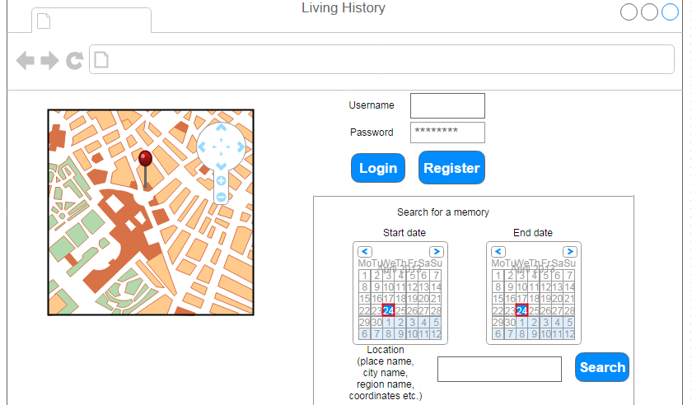

On the main page, there will be a text box for typing in username and a textbox for password. The user may login using these controls, or he may click on the Register button to register if he is not already registered.

There will be a search section to look for memories in a time range in a particular location. Note that this location can be in various granularity levels. It can be a place name such as “Bogazici University North Campus”, a town name such as “Izmir”, a region name such as “Southern Turkey” or exact coordinates such as 23N 30E.

There will be a map visible on the left part of the screen. This can be at a fixed location for each visit of the website or at the place where the user left it the last time.

**Requirement-1:** Users shall be able to log in by providing their username and password. There shall be a login section on the main page and the login page shall be displayed anytime when the user requests a resource that requires authentication. Anonymous users can search for memories and view them on the map. However they cannot add new memories. Only logged in users can add their memories.

**Requirement-2:** Users shall be able to search for a memory in a certain place in a certain time range by providing this information. The time variable shall have the resolution of day, that implies that the user cannot make a search such as “1 March 1993 13:55”. The location variable can be anything from a region name or country name to exact geographical coordinates. It can also be a tag name. (We will refer to this)

**Requirement-3:** When the user accesses the application from his web browser, the system shall make a call to open-source repositories for information about a place. The system shall then use this retrieved data to populate the map with previously entered bits of memory. The system shall use the GoogleMaps API for displaying the map to display the memories in.

* 1. **User page and functions**

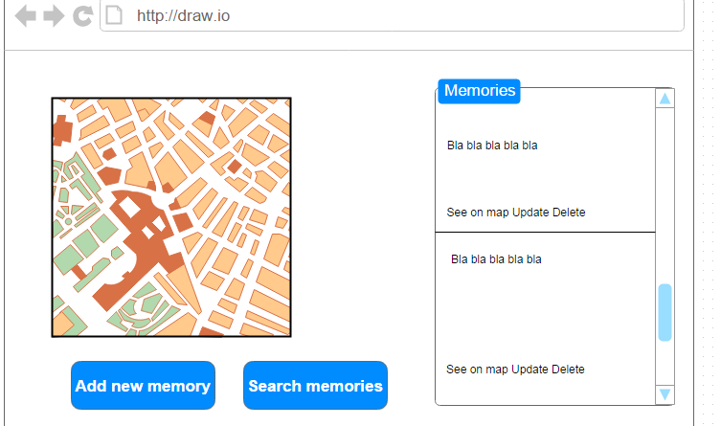

The user page will be displayed after the user successfully logs in. On the right hand side the user will see all the memories he has entered so far. For each memory, the box will contain hyperlinks: See on map, Update and Delete. The See on map link will, once clicked, navigate the map displayed on the left hand side to the exact place of the memory. The Update link, once clicked, will display an Update box on the screen. The user can use it to update the memory. Clicking on the Delete link will delelte the memory altogether. The user can add a new memory by clicking on the Add new memory button. (To be described in detail in the following section.)

**Requirement-4:** The user shall be able to see his memory more clearly on the map by clicking on the See on map link. This shall be displayed in a popup on the map.

**Requirement-5:** The user shall be able to update his memory by clicking on the Update link. The Update window will be displayed. The user can change the message body, the tags, the location, the time range and the geographical coordinates.

**Requirement-6:** The user shall be able to delete his memory. When he clicks on the Delete link the memory will be deleted from the system and the box displaying all memories of the user will be updated automatically.

* 1. **Memory page and functions**

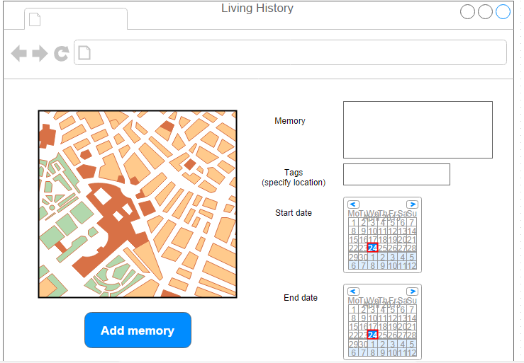

The memory page is displayed after the user has clicked on the Add new memory button on the user page. On this page, the user uses the controls to create a new memory. The user types the memory in the memory text area and provides tags fort he memory using the tags text box. The location of the memory (such as Bogazici University, Istanbul or Germany) will be specified here along with other tags related to the memory. If the user does not specify the location, the location will only be defined by the geographical coordinates pinpointed on the map. So, for search queries that do not specify geographical coordinates it won’t be found. Then the user specifies a location on the map by clicking on it and the coordinates are thus specified. Then the user selects the start date and end date. The rationale for the start date and end date is for memories that have a continuous characteristic. For example, someone might have been visiting a specific place for three months. If the memory is confined to a specific day, the user can set the start date and end date to be equal to each other. After completing all fields the user can click on the Add memory button and a new memory is created. If the user has not filled in all the fields he will be prompted to do so by displaying a message on the screen and the process will not continue until all fields are filled out.

**Requirement-7:** The user shall be able to create a new memory by specifying the message body, the time (or time range), the exact geographical location (on the map), the location and any additional tags. All of these fields are mandatory.

* 1. **Admin page and functions**

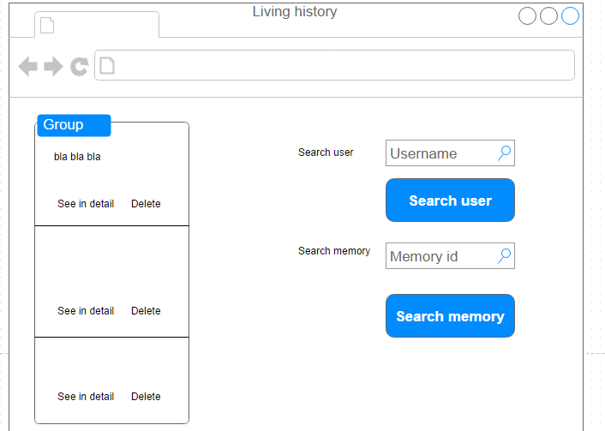

Admins, unlike regular users, will be authorized to delete any memory in the system. Admins may delete memories that are found to be abusive or that clash with the policies of the web application. On the left hand side there will be a box that displays all memories that have not yet been evaluated by an admin. These are listed starting from the most recently added. The admin can click on the See in detail link upon which all the fields of a memory will be displayed. The admin can then click on Delete to delete the memory or click on Approve on the new page to approve it. Admins can also search for a specific user by his username or search for a memory by its id.

**Requirement-8:** Admins shall be able to delete or approve a memory. A memory can be deleted if it is abusive or clashes with the policies and can be approved otherwise.

**Requirement-9:** Admins shall be able to search for a memory by entering its ID. When the memory is found in the system database the admin can display the memory in detail.

**Requirement-10:** Admins shall be able to search for a specific user by entering his username. When the user is found all his personal information will be displayed along with all his entered memories.

* 1. **Registration page and functions**

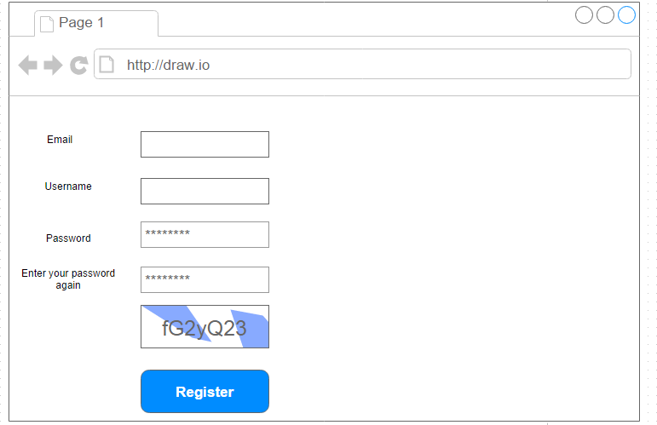

Users shall be able to register for the application if they’re not already registered. The user enters his email, his username and his password and his captcha answer and clicks on Register. The email and username must be unique. If they already exist he will be prompted to change them. The user will enter his password twice. If the passwords do not match a message will be displayed.

**Requirement-11:** A user shall be able to register to the system by providing a username, an email and a password. The username and email must be unique.

1. **Requirements**

The requirements elicited so far are listed below. In later stages of the software delvelopment lifecycle these requirements may be revised.

**Requirement-1:** Users shall be able to log in by providing their username and password. There shall be a login section on the main page and the login page shall be displayed anytime when the user requests a resource that requires authentication. Anonymous users can search for memories and view them on the map. However they cannot add new memories. Only logged in users can add their memories.

**Requirement-2:** Users shall be able to search for a memory in a certain place in a certain time range by providing this information. The time variable shall have the resolution of day, that implies that the user cannot make a search such as “1 March 1993 13:55”. The location variable can be anything from a region name or country name to exact geographical coordinates. It can also be a tag name. (We will refer to this)

**Requirement-3:** When the user accesses the application from his web browser, the system shall make a call to open-source repositories for information about a place. The system shall then use this retrieved data to populate the map with previously entered bits of memory. The system shall use the GoogleMaps API for displaying the map to display the memories in.

**Requirement-4:** The user shall be able to see his memory more clearly on the map by clicking on the See on map link. This shall be displayed in a popup on the map.

**Requirement-5:** The user shall be able to update his memory by clicking on the Update link. The Update window will be displayed. The user can change the message body, the tags, the location, the time range and the geographical coordinates.

**Requirement-6:** The user shall be able to delete his memory. When he clicks on the Delete link the memory will be deleted from the system and the box displaying all memories of the user will be updated automatically.

**Requirement-7:** The user shall be able to create a new memory by specifying the message body, the time (or time range), the exact geographical location (on the map), the location and any additional tags. All of these fields are mandatory.

**Requirement-8:** Admins shall be able to delete or approve a memory. A memory can be deleted if it is abusive or clashes with the policies and can be approved otherwise.

**Requirement-9:** Admins shall be able to search for a memory by entering its ID. When the memory is found in the system database the admin can display the memory in detail.

**Requirement-10:** Admins shall be able to search for a specific user by entering his username. When the user is found all his personal information will be displayed along with all his entered memories.

**Requirement-11:** A user shall be able to register to the system by providing a username, an email and a password. The username and email must be unique.